**Assingment 2 Test Case**

**18-May-2019**

**Case 1 – Create a new DFA**

1. **Initial prompt**

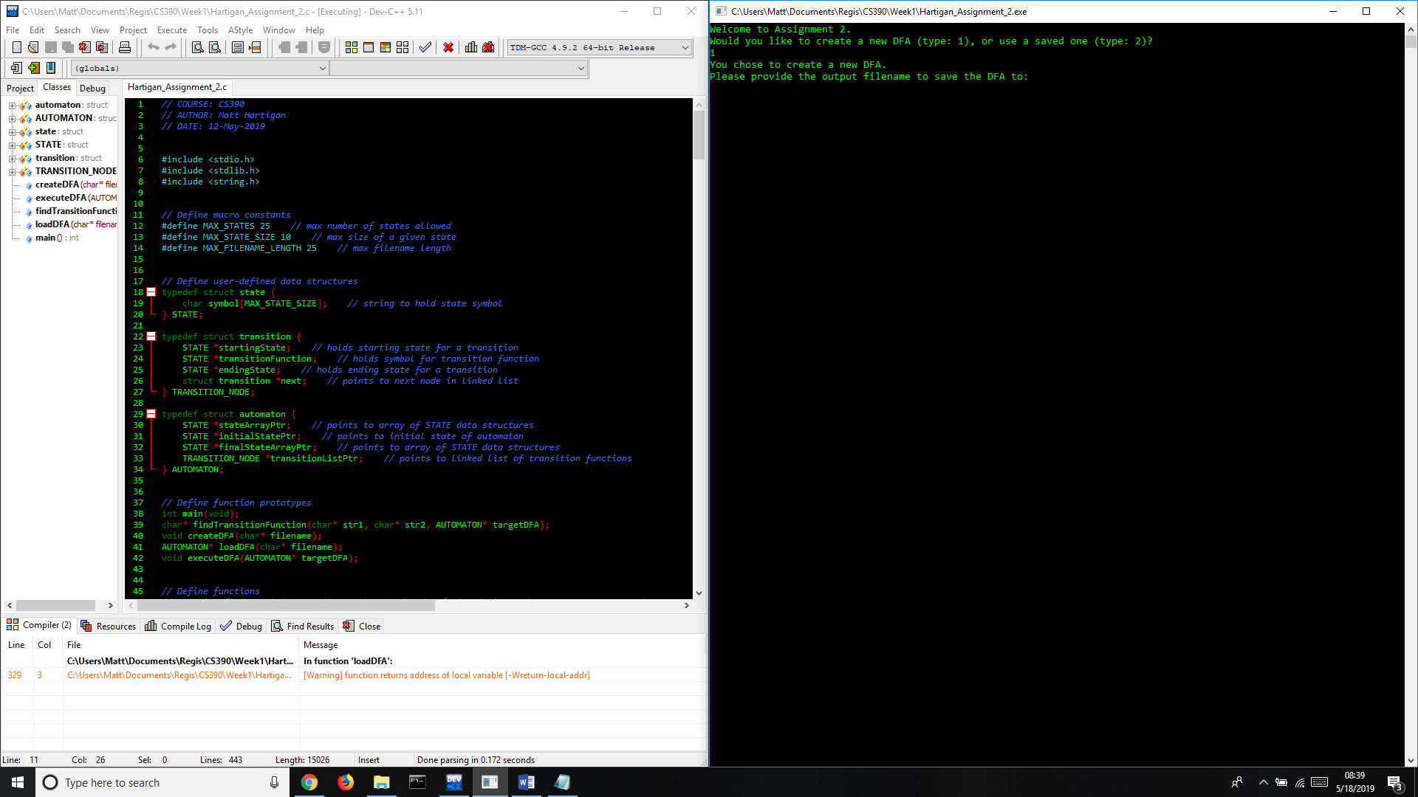

1. **Enter input for DFA as prompted on screen**

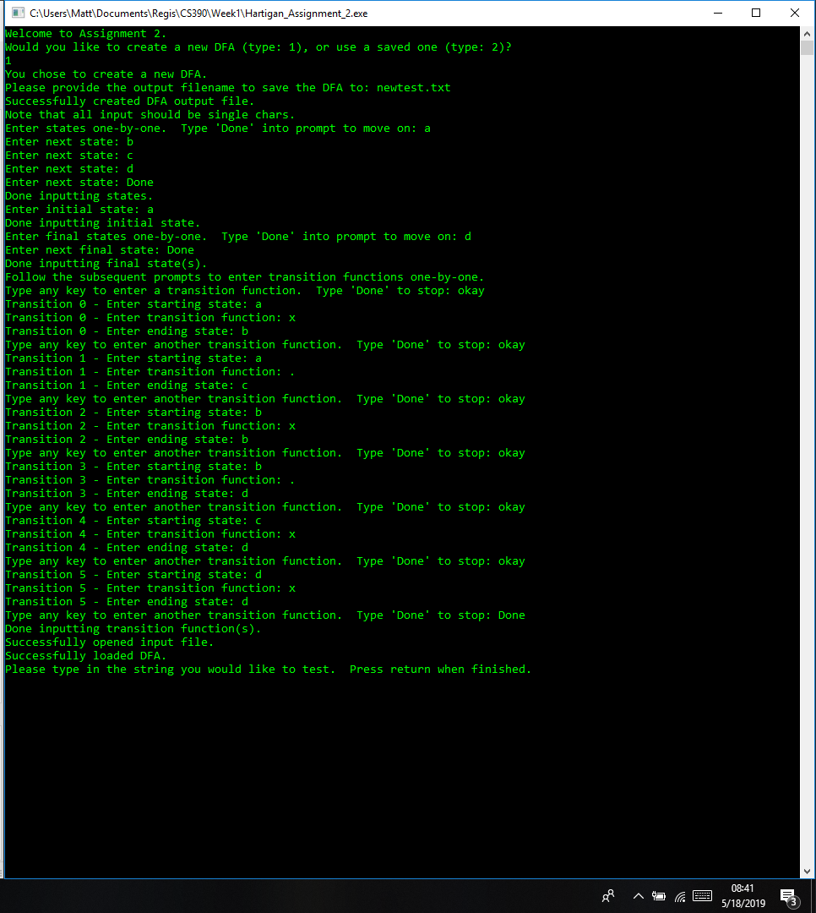

1. **Successful test using string ‘ax.’ and the input DFA**

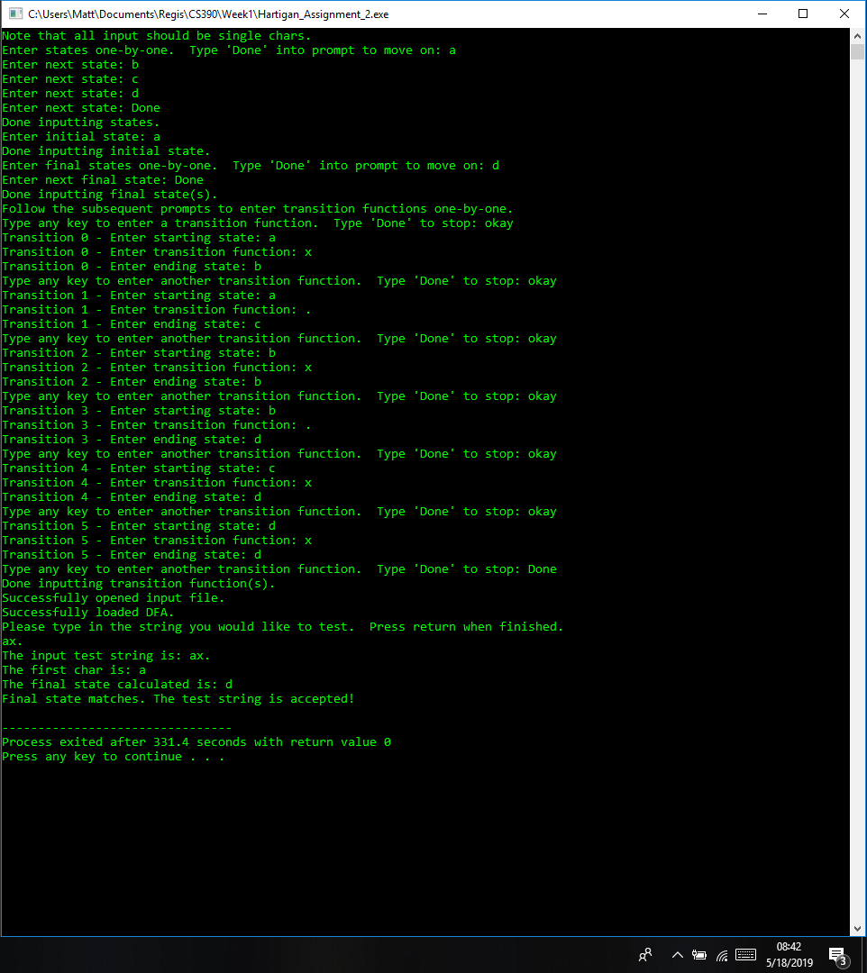

**Case 2 – Use a saved DFA**

1. **Initial prompt**

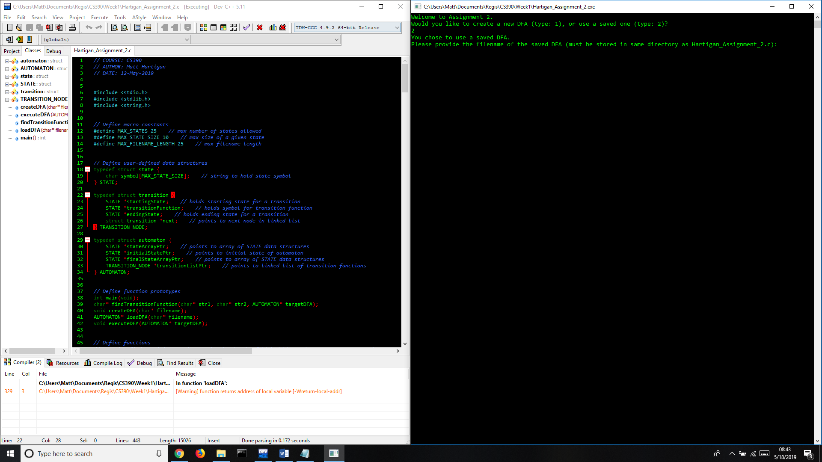

1. **Load DFA created during Case 1**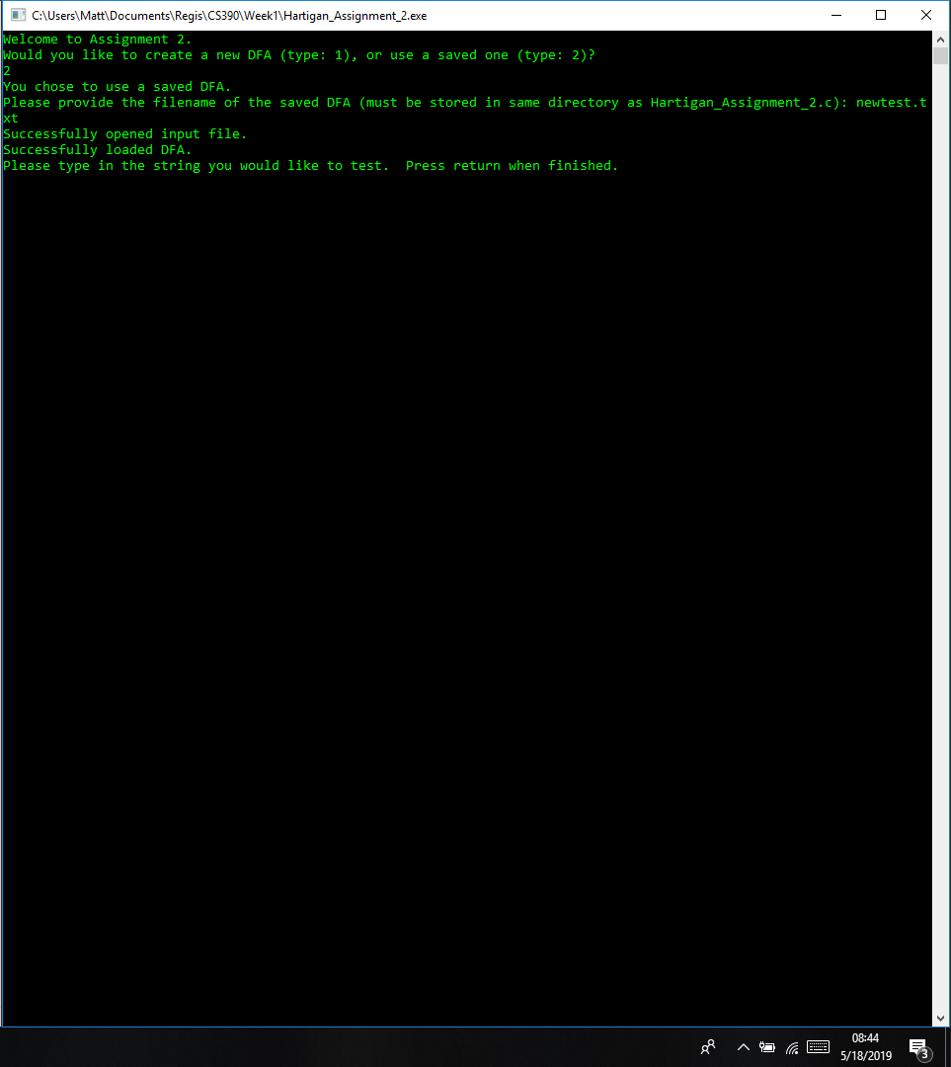
2. **Successful test using string ‘ax.’ and the input DFA**

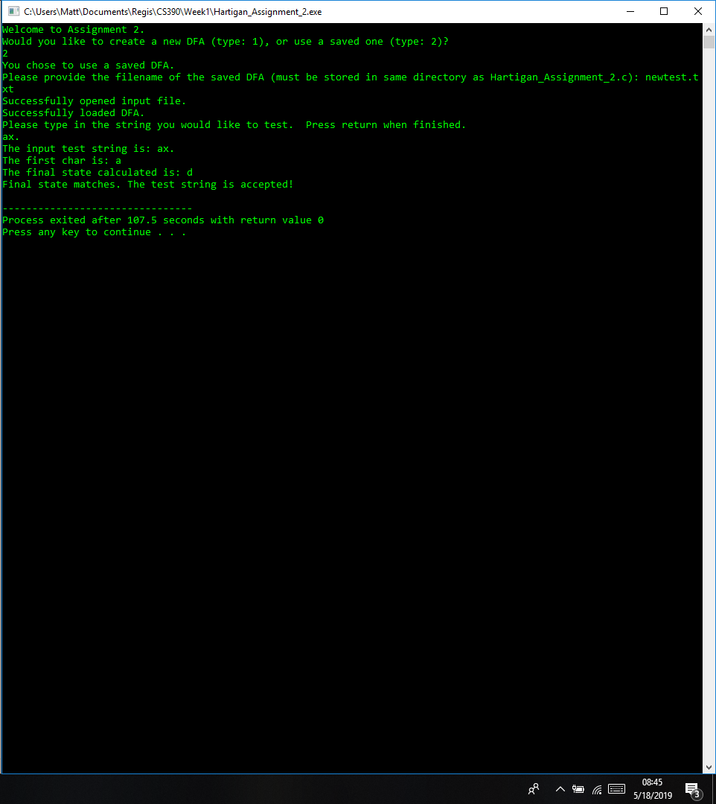

**‘newtest.txt’ DFA input file**

